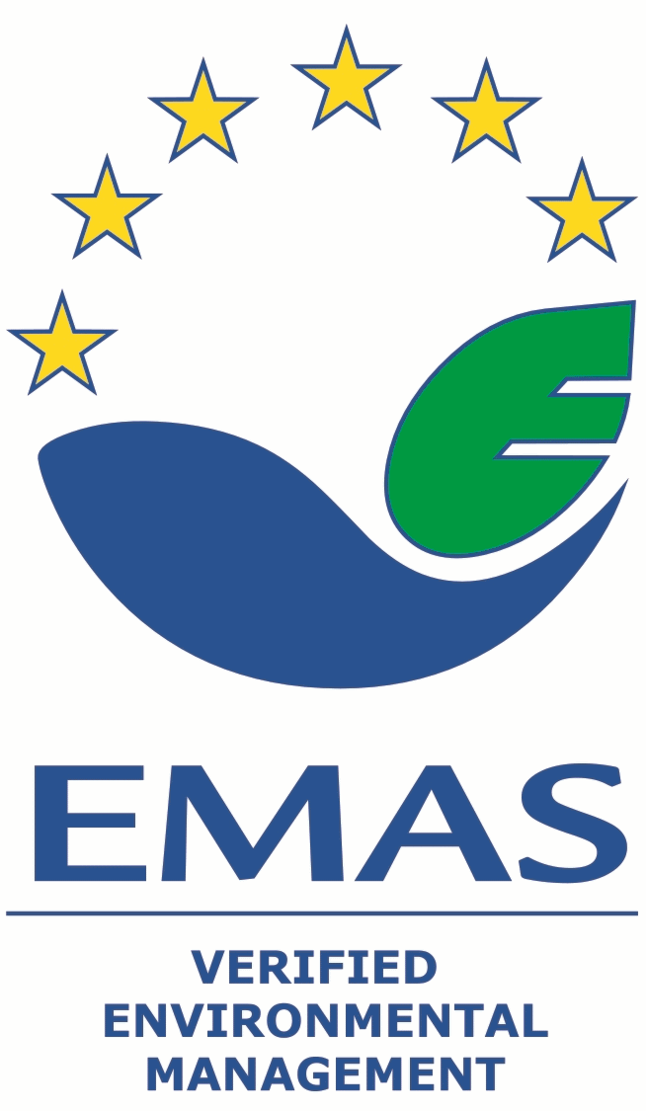
EMAS Awards
Application Form & Factsheet

Contributing to make the European economy more circular
_____________________________________________________________________More information: http://ec.europa.eu/environment/emas/emas_for_you/emas_awards_en.htm

FACT SHEET
Introduction
The European EMAS Award is the most prestigious award in environmental management and has been presented to EMAS registered organisations nearly every year since 2005. Since 2015 the Awards take place every two years, alternating with the European Business Awards for the Environment (EBAE). The EMAS Awards were established by the European Commission and reward top environmental performance of EMAS registered organisations.

This year’s topic
For this year’s edition of the EMAS Awards, the Forum of Competent Bodies and the European Commission have decided to acknowledge the achievements of EMAS registered organisations that have undertaken significant efforts and initiatives to contribute to making the European economy more circular and whose achievements can inspire others to do the same.
The main aim of a Circular Economy is to ensure that the resource yield is optimised and that natural capital is preserved.
A Circular Economy is about taking an integrated approach to product and process sustainability so as to keep the value of products, services and materials in the economy for as long as possible and minimise waste. Frontrunner organisations will without doubt already be thinking about how they can address several of their product or service stages in an integrated manner.
The European Union (EU) has identified the Circular Economy as a topic of key importance on its political and economic agenda and in 2015 produced an ambitious Circular Economy Action Plan. With their systematic environmental management processes, EMAS registered organisations are well-placed to take pioneering steps in making this a reality. The EU is looking to maximise the impact of Circular Economy Strategies in the context of EMAS. That is why the EU wants to identify the best strategies and measures taken by EMAS registered organisations and boost their visibility to promote their replication across the EU.

Eligibility
EMAS registered organisations in the following three categories can apply:
- private micro, small and medium-sized organisations (SMEs);
- private large organisations;
- public organisations
Nominees from each of these categories are selected at national level by the national Competent Bodies.
Organisations who have won an EMAS Award in the most recent edition of the EMAS Awards cannot apply for the EMAS Awards 2017.
Applications are eligible provided that the organisation is able to demonstrate that:
- their circular economy-oriented initiatives and measures have been ongoing during the time that they are EMAS registered. An organisation is eligible even if these initiatives and measures were initiated before their EMAS registration
- a conclusive reference is made to the circular economy initiatives and measures, or to the overall plan that includes these initiatives and measures within the environmental statement.
Since the concept of a circular economy is a relatively new ambition in practice the EU is looking for early but promising efforts and initiatives on the path towards circularity. We therefore invite you to fill in the criteria below that you deem relevant to the activities of your organisation. You do not need to address all criteria, but please bear in mind the distribution of points as indicated below.

Jury
The EMAS Award nominees from the Member States will be evaluated by an independent EMAS Awards Jury, consisting of renowned experts in the field of EMAS and Circular Economy. A representative of one of the organisations that has recently won an EMAS Award will also be a member of the jury.

Assessment and practical information
For the assessment of a nominee’s application the jury will take inspiration from the European Commission’s Communication "Towards a circular economy: a zero waste programme for Europe".
, Circular Economy is a transversal approach and the four indicative stages are the following:
- Procurement and sourcing of sustainable services/ products
- Development, production and provision of sustainable services/ products / business models designed to assure resource efficiency, facilitate reuse/ repair/ recycling, remanufacturing or allow a longer usage.
- Resource efficient production and distribution processes
- Waste management, recycling and industrial symbiosis
Applicants can demonstrate their achievements by focussing on those stages where their organisation is contributing to a Circular Economy. However organisations demonstrating initiatives with a transversal impact on more than one stage will get extra points based on the 2nd criterion developed below (“Initiative(s) in your organisation that have been designed to have a positive impact on different steps of the life cycle”).

Award criteria for circular economy measures related to environmental performance
When filling in the application form, please make reference to the page(s) in your environmental statement where the initiative or achievement you would like to highlight is covered.
The following main and supportive criteria for the EMAS Awards focus on different aspects of a Circular Economy in the context of an EMAS implementation:

EMAS Award criteria (max. 100 points)

- Development and implementation of initiative(s) fostering a more Circular Economy (60 points)
Under this award criterion please explain how and to what extent your organisation has implemented one or more initiatives contributing to making the operations or the business model of your organisation more circular.
Such initiatives can address one or more of the following drivers of a circular economy:

- Optimisation of the yield of resources
How has your organisation taken into account the efficiency of the different resources that you deploy, and to what extent has this efficiency been maximised?
Please note that the resource efficiency should not impact on the quality of the product or service delivered.

Examples
- An initiative has as its goal to redesign a specific part of a product to minimise the volume of material needed to produce this part, without any utility or quality decrease. Moreover the design of the product has been improved so that logistics can be ameliorated (more product units fit in one truck).
- Similar types of improvements can be applied to the resources necessary to deliver a service. For example an efficient management of lights, heating and cooling processes can deliver significant benefits within service organisations, such as a tourism establishment.
- An organisation that offers transport and logistics services could review their processes with an aim to include reverse logistics, for example collecting office waste or packaging waste when making deliveries
- Another example would be a new business model that allows the delivery of existing services but with lower resource consumption (such as temporary car sharing).

- Improvement of the design of products and processes to decrease their environmental impact and to keep the value and utility of products and services in the economy for as long as possible
How and to what extent has your organisation designed relevant products or services to allow for a longer usage and/or to facilitate reuse, repair, remanufacturing or recycling; or how has your organisation established processes that achieve the same objective?
Your initiative should be avoiding the quick and irrevocable deterioration of products or services and contribute to keeping the value of the products or services in the economy for as long as possible. Such approaches should reduce maintenance, repair or replacement costs and decrease environmental impacts.

Examples
- The organisation has designed a product in a way that allows it to be easily dismantled so that parts can be easily replaced without reducing the initial value of the product. Moreover the organisation has provided repair guidance, helping distributors or clients to easily repair the products.
- Instead of selling its products the organisation proposes a leasing solution and a constant maintenance service that allows the product to be repaired, adapted or replaced.
- By adapting its processes, an organisation delivering services has decreased its negative environmental impact. This has been the case in many tourist accommodations that manage to reduce disposable items, water and detergent consumption, etc.

- Waste minimisation, recycling and industrial symbiosis
Please explain how and to what extent your organisation has minimised or avoided waste generation.
Waste can be minimised by creating a virtuous cycle that makes use of specific technical or biological components of a product that is reaching its end of life. The same approach can be used regarding materials used to deliver a service. This cycle could be based on recycling, reuse for similar application, remanufacturing or participation in industrial symbiosis processes where components considered as potential waste by one industry are used as a resource by another industry.
You should demonstrate how your initiative contributes to minimising waste via the creation of virtuous cycles.
Examples
- When a component of a product is defective the producer has ensured that it can easily be replaced to prolong the life of the product. Beyond this option, the component is also included in a virtuous cycle. Depending on the defect it can either be repaired or remanufactured for future similar usage, or sold to a dismantler for resource efficient and profitable recycling.
- Components from existing materials could be reused and upcycled to be incorporated into new products. For example, an office furniture designer uses the discarded office furniture from their clients to build new furniture matching a new interior design.
- Collected waste can be used as a raw material. For example a waste collector sells their PET to a local company producing plastic fibres for 3D printers. Another company gathers olive pits to transform them into small briquettes for heating.
- In the catering sector, food waste can be avoided and the value of the potentially wasted food maximised by preventing leftovers and applying a clear waste hierarchy ranging from donation to anaerobic digestion.

- Initiative(s) in your organisation that have been designed to have a positive impact on several steps of the life cycle (max. 20 points)
Under this award criterion please explain how and to what extent your chosen initiative(s) have generated a positive impact on different stages in the life cycle of a product or service.
Ideally, the initiative(s) will have been designed in such a manner that they can create benefits, increase resource efficiency and minimise waste at every stage of the life cycle. To achieve this, the initiative(s) should not only consider internal processes but also practices of external stakeholders such as suppliers, clients, or dismantlers.

Examples
- From its conception an improved product has been designed to minimise the resources needed at the manufacturing stage, made more robust to increase its lifetime, and developed to allow easy reparability and lower energy consumption at the use stage. The conception of the product has also addressed the design and origin of the different components that can easily be repaired, reused or recycled with minimal losses of value.
- Similarly, a service provider can consider a range of factors in their processes that will minimise the negative impact of the inputs used to deliver a service, such as: the environmental footprint of their suppliers, internal process optimisation, and a specific waste policy.

- Business and social relevance of the initiative(s) (max. 20 points)
Under this award criterion please explain how and to what extent the initiative(s) have generated a positive return on investment, to what extent they have contributed to creating jobs, and to what extent they have a proven social utility.
When considering social relevance you should take into account the capacity of the initiative(s) to create sustainable jobs and to provide added value to the society as a whole.
Examples
- To make the initiative profitable the organisation has decided to modify its marketing approach. Instead of creating revenue based on the frequent upgrading of the product the organisation has opted for a strategy of differentiation based on a better quality, longer lifetime and reparability of the product. Thanks to this improved product and the subsequent improved brand image the organisation has been able to gain market share. Moreover, additional revenue has been generated by the valorisation of product components.
- The initiative has also generated social benefits since the components can be repaired locally (job creation). Moreover, individual consumers can make use of the product over a longer period of time and invest the budget previously allocated to its replacement in other spending.
- Similarly, in the service sector a company running the leasing of products may decide to increase its repair capacity. This would increase the lifetime of is assets but can also create jobs for workers whom the organisation would train in those specific operations.

Supportive EMAS Award criteria (max. 25 points)

The supportive criteria are EMAS-specific and allow you to demonstrate how the use of EMAS has been central to developing the initiatives you described above.
To demonstrate this you can refer to the following possible links between EMAS and the Circular Economy driven initiative(s). We invite you to go beyond this list if you can think of further links. .
- Identification or development of Circular Economy driven initiatives and opportunities based on the direct and indirect environmental aspects identified in the context of an EMAS implementation.
- Extent to which the initiative(s) match your organisation’s environmental vision and policy as developed in the context of EMAS.
- Use of EMAS to monitor environmental progress and (if needed) take further action associated with the implementation of your Circular Economy initiative(s).
- Employee participation in the development of the initiative(s) with a view to improving the environmental performances of your organisation.
- Promotion of the initiative(s) based on data validated by the environmental verifier and presented in the environmental statement.

Application FORM
(with max. 3-5 pages descriptive supportive info (ARIAL 11))

INFORMATION ON THE NOMINATED ORGANISATION

Please indicate in which of the following EMAS Awards categories you want to be nominated

Per country, one organisation of each of the following three categories can be nominated by the national Competent Body (Bodies).

Organisations from the private sector:
Private micro, small or medium: micro-, small or medium-sized organisations - employing fewer than 250 persons and having an annual turnover not exceeding 50 million €, and/or an annual balance sheet not exceeding 43 million €.

Private large: large organisations - employing more than 250 persons and having an annual turnover exceeding 50 million €, and/or an annual balance sheet exceeding 43 million €.

Organisations from the public sector:
Public: small or large organisations

Name of the organisation:

Name of the contact person:

E-mail:

Telephone:

Address:

Country:

EMAS Registration number:

Please specify if you have already participated in the EMAS Awards before:

Yes No

If yes, please indicate the year/s in which you participated: ________________

Award category/ies: _____________

If applicable, what status was the organisation granted at the national level competition?

Winner
Nominee

Stages that your organisation is contributing to (you can select more than one stage):

Procurement and sourcing of sustainable services/ products
Development, production and provision of sustainable services/ products / business models designed to assure resource efficiency, facilitate reuse/ repair/ recycling, remanufacturing or allow a longer usage.
Resource efficient production and distribution processes
Waste management, recycling and industrial symbiosis

DESCRIPTIVE INFORMATION ON THE AWARD CRITERIA

Please make reference to the page(s) in your environmental statement where the initiative or achievement you would like to highlight is covered.

Main EMAS Award criteria (max. 100 points)

- Development and implementation of initiative(s) fostering a more Circular Economy (60 points)

English description of how you have implemented initiatives that support a circular economy, by optimising the yield of your resources, improving the design of your products and processes and/ or minimising waste through for example recycling, remanufacturing or industrial symbiosis. Please also include additional informative descriptions you consider useful to elucidate the actions of your organisation in relation to this award criterion.
…………………………………………………………………………………………………………………………….
…………………………………………………………………………………………………………………………….
…………………………………………………………………………………………………………………………….
…………………………………………………………………………………………………………………………….
……..(Please use (a) separate page(s) when necessary and limit your contributions to around 1000 words)

- Initiative(s) in your organisation that have been designed to have a positive impact on several steps of the life cycle (max. 20 points)

English description of how initiative(s) in your organisation have taken different stages of the life cycle into account and are creating benefits for several stages, as well as additional informative descriptions you consider useful to elucidate the actions of your organisation in relation to this award criterion. The initiative(s) should not only consider internal processes but also practices of external stakeholders such as suppliers, clients or dismantlers.
…………………………………………………………………………………………………………………………….
…………………………………………………………………………………………………………………………….
…………………………………………………………………………………………………………………………….
…………………………………………………………………………………………………………………………….
……..(Please use (a) separate page(s) when necessary and limit your contributions to around 1000 words)

- Business and social relevance of the initiative(s) (max. 20 points)

English description of how and to what extent the initiative(s) have generated a positive return on investment, have contributed to creating jobs, and have proven to have specific social utility, as well as additional informative descriptions you consider useful to elucidate the actions of your organisation in relation to this award criterion.
…………………………………………………………………………………………………………………………….
…………………………………………………………………………………………………………………………….
…………………………………………………………………………………………………………………………….
…………………………………………………………………………………………………………………………….
……..(Please use (a) separate page(s) when necessary and limit your contributions to around 1000 words)

Supportive EMAS Award criteria (max. 25 points)

Demonstrate how the use of EMAS has been central to the developing the initiatives described above.

Explain the links between the use of EMAS within your organisation and the development of your Circular Economy driven initiative(s).

………………………………………………………………………………………………………………………….
…………………………………………………………………………………………………………………………….
…………………………………………………………………………………………………………………………….
…………………………………………………………………………………………………………………………….

- Specify which supporting materials you have annexed to this application form:

Annex 1: Mandatory English descriptive summary of the circular economy initiative(s) developed.
Annex 2: Mandatory description of actions related to the supportive award criteria.
Annex 3: Mandatory (electronic) copy of the EMAS environmental statement.
Annex 4: ………………………………………………………………………………….
Annex 5: …………………………………………………………………………………

European Commission Circular Economy Strategy: http://ec.europa.eu/environment/circular-economy/index_en.htm
http://eur-lex.europa.eu/legal-content/EN/TXT/?uri=CELEX:52014DC0398R%2801%29

